**Kieu Que Thanh Nguyen**

**Student ID:** 101354326

Load Testing on Web Application

Performance Test Proposal

Semester 2, 2019

Table of Contents

1. Executive Summary 2

2. Context and Background 3

2.1 Introduction 3

2.2 Process and Criteria 3

3. Design and Justification 5

3.1 Scenario 5

3.2 Design and Approach 6

3.4 Tools and System Requirements 7

3.5 Planning and Delivery 7

4. Conclusion 9

5. Reference 10

List of Tables

Table 1: Supposed outlined requests to Australian Vodafone Website 5

Table 2: Performance Test Scripts by Steps 6

# **Executive Summary**

This paper is a proposal for Topics in Computer Science unit (COS40004) to present how a load testing on web application works and is designed by applying the load testing process in supposed case: Australian Vodafone Website - <https://www.vodafone.com.au/> . The objective of the paper also prescribes the criteria, scenario, approach, testing environment and a planning for the test.

# **Context and Background**

## **Introduction**

Web application have become a intergral part of the business. Therefore, executing the performance testing, a means of quality assurance, is critical to sustain the business growth. Performance testing prefers to a non-fuctional testing process to value the performance of an application under their expected workload.

Performance criteria is defined in preliminary investigation and performance testing is conducted in final construction and after implementation in software development life cycle. One method or subsets of performance testing is load testing. By running a specified set of scripts that emulate user behavior at different load levels, the load testing allows testors to assess how the website meets the customer expectations on two measures: stability and speed.

* Stability measures the percentage of time users can access the website. It is a key factor which impacts on the success of business transactions.
* Speed measures end-to-end response time to determine how user retrieve data. Speed is also an important factor because of its lead to delays and lost business opportunities.

## **Process and Criteria**

As Figure 1 below shows, load testing can measure performance of web application based on actual customer behavior. The load generator will generate virtual users and constinously submit the requests to the website. Based on those requests, a number of interaction scripts with test parameters as a realistic load are created and modified by script recorder before its submission against the website. During the time the website is subject to the load generated and based on the number of virtual users, the performance metrics such as response time, throughput, … are measured and valued.

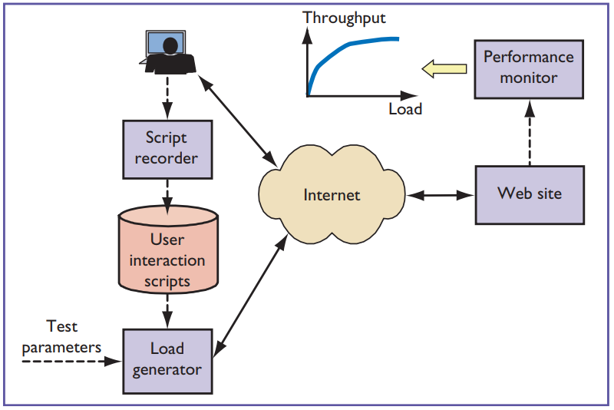

**Figure 1:** *The load-testing process*

Since, the performance of a website can be influenced by other factors, such as connection bandwidth or graphical location, there is no existing standards for load testing while its requirements based on the business requirements with a variety of performance metrics:

• Expected response time (time required to send a request and receive a response)

• Anticipated error rates

• Average throughput (requests/load time)

• Average latency time

# **Design and Justification**

## **Scenario**

The Australian vodaphone website (<https://www.vodafone.com.au>) must support 22 million customers which will on average generate about 184 transaction requests every 30 minutes as figure 2 below:

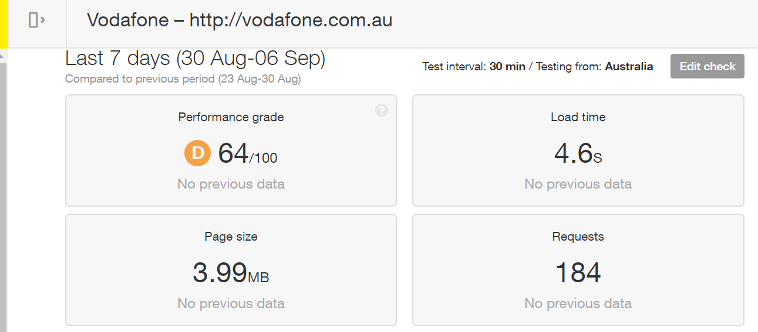

**Figure 2:** *Vodafone website’s performance report from Pingdom.com*

We suppose that there are about 10 transactions requestes of 10 different users every seconds that Australiaa Vodafone website (<https://www.vodafone.com.au/>) gets in the peak house. The requests include the portal and login as outlined in the table 1 below.

|  |  |  |  |
| --- | --- | --- | --- |
| **No.** | **Scenario** | **Pages** | **Total** |
| 1 | Launch the homepage | Homepage | 2 |
| 2 | Surfing news | About Vodaphone, Hot Offers, Phone Plans, Prepaid Plans, Bundle news, Support Service | 3 |
| 3 | Login and Log out | LoginToMyVodafone, VodafoneLoginPage, MyVodafone Page, Usage history, Purchase History, Logout | 5 |
|  |  | **Total** | 10 |

**Table 1:** *Supposed outlined requests to Australian Vodafone Website*

## **Design and Approach**

A load test will be conducted based on the scenario by using Apache Jmeter to measure and value the performation metrics on the criteria and requirements and then test results is produced. Based on table 1, we will conduct a load test by generating 10 different connection requests of 10 user at the same time every a second to measure the load based on the metrics. We will operate the test to record the test results by portal, enter, login and log out the website by steps.

|  |  |  |
| --- | --- | --- |
| Step | Transactions | Describe |
| 1 | Lauch Vodafone Hompage | Enter URL <https://www.vodafone.com.au/> to view Homepage |
| 2 | Viewing pages:   * AboutVodaphone * Hot Offers * Phone Plans * Prepaid Plans * Bundle news * Support Service | Enter URL addrress of those pages or click those pages to access and view information |
| 3 | Access MyVodafoneLogin | Click on Login to MyVodafoneLogin to go: https://www.vodafone.com.au/my-vodafone |
| 4 | Click on the ‘Login Now’ button in MyVodafoneLogin page | After click on ‘Login Now’ button, user will go to https://auth.myvodafone.com.au/login?code=uxr |
| 5 | Enter username & password and click on ‘Login’ button | Go to the account’s homepage to view account balance  https://myaccount.myvodafone.com.au/ |
| 6 | Click on ‘View History” => “Usage History” | Go to <https://myaccount.myvodafone.com.au/usage> to view the Usage History |
| 7 | Click on ‘View History” => “Purchase History” | Go to <https://myaccount.myvodafone.com.au/purchase> to view the Purchase History |
| 8 | Logout | Click on Logout https://myaccount.myvodafone.com.au/signout |

**Table 2***: Performance Test Scripts by Steps*

## **Tool and system requirements**

JMeter is a testing tool which is used to test and analyze the load on client and server applications.

Reason to choose:

* JMeter has an unlimited load generation capacity while LoadRunner has a limited load generation capacity.
* Jmetter is free while others are expensive

## **Planning and Delivery**

The process of load testing can be broken down into three phases: planning, testing, and analysis. The planning of load testing project is showed by the Grantt Chart in the figure 3 below.

Planning phrase

* Define the objectives and deliverables and set expectations.
* Define workload.
* Select performance metrics to collect.
* Identify tests to run and decide when to run them.
* Decide on a tool option and generating loads.
* Write a test plan; design user-scenarios and create test scripts.

Testing phrase

* Setup Environment (e.g., set up the test bed and performance monitors on the network and servers).
* Run tests.
* Collect data.

Analysis phase

* Analyze results.

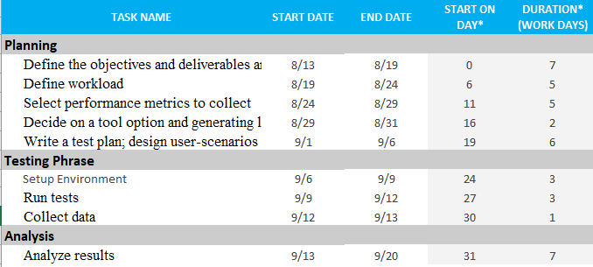

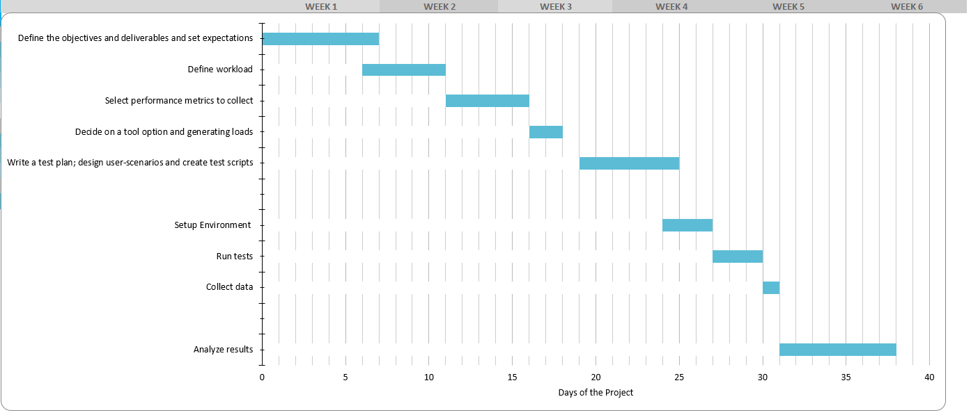

**Figure 3***:* *Grantt Chart of The Testing Project*

# **Conclusion**

This paper explains the process of a Load Testing and clarifies the critera for the test. This document also prescribes the testing scenario, approach and design as well as test planning and environment to test the performance of Australian Vodafone website.

# **Reference**

Hung, Q N, Bob, J & Michael, H 2003, Testing Applications on the Web: Test Planning for Mobile and Internet-Based Systems, Second Edition, John Wiley & Sons.

Rodrigues, A G, Bruno, D, & Philippe, M 2019, *Master Apache JMeter - from Load Testing to DevOps : Master Performance Testing with JMeter*, Packt Publishing.